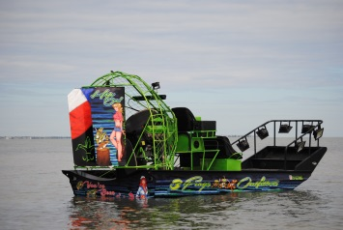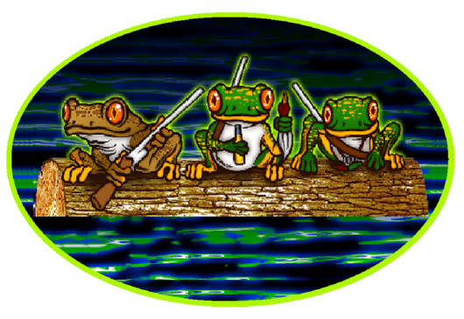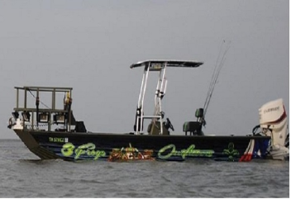
“Day Trip” Duck Hunting or Bowfishing !!
- For our duck hunting guests you will arrive on your scheduled day at the boat ramp of our choice depending on where the ducks are in the Rockport Tx area. We’ll set a time of arrival. This is a drop off hunt and are not guaranteed. Our all inclusive hunts are guarateed opportunity or half price.
- Guests will be transported by Airboat to our hunting area and dropped off. We supply decoys and we will put them out. 10:30 is pick up time unless you’re done early.
- The price for this hunt is 100.00 per person per day with a 2 person minimum. If you have a party of 3 the price will be 250.00 party of 4 the price will be 300.00 an additional 75.00 per person up to 8
- We also offer a fully guided hunt with our guides, dog, & decoys. You do nothing but shoot ducks. The price for this hunt is 150.00 per person per day minimum party of 2 & maximum party of 8
- For our bowfishing guests you will arrive on your scheduled day at the boat ramp of our choice depending on where the fish are in the South Tx area. We will set the time of arrival.
- Guests will be transported in our custom Airboat or 24’ bowfishing boat to our fishing area for 4 to 6 hours of shooting action.
- The price for this trip is 150.00 per person per day minimum party of 2 maximum party of 6. Each additional person after 2 is 100.00 each
- We can customize a day of both duck hunting & bowfishing. Just let us know what you want to do and we will make it happen.
Things to bring for duck hunting: 12 or 20 gauge shotgun, shotgun shells, (steel shot only) hunting license, camouflage jacket, waders, rain gear (just in case) & ice chest of suitable size for ducks. Don’t forget the federal duck stamp on your license.
Things to bring for bowfishing: Fishing license, rain gear (just in case) & you can bring your own bow if you prefer but we will supply them.

